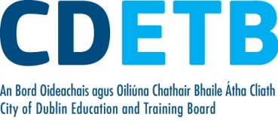
Purchase Order Report 2022 - Quarter 1

Purchase Orders over €20,000 by Quarter

Purchase Orders of €20,000 or above for
City of Dublin Education and Training Board
1st Quarter 2022

PO Number | Supplier | Total | Description | Paid
PO759798 | Cabinpac Limited | 556,310.41 | Construction Works | Y
PO749207 | Capita IB Solutions | 326,392.80 | SUSI Online Grants | N
PO737009 | Dell Computer Corporation | 130,908.69 | Server | Y
PO755037 | Office of Comptroller | 92,200.00 | 2020 Audit | Y
PO758584 | Henry Ford & Son Ltd | 49,010.00 | Minibus Purchase | N
PO755383 | Capita IB Solutions | 41,512.50 | SUSI Online Grants | N
PO759318 | Eir Evo | 36,414.84 | Hosting | Y
PO755089 | Empire Roofing Ltd | 29,816.45 | Roof Repairs | Y
PO758986 | Dell Computer Corporation | 25,030.50 | Desktop Computers | N
PO759542 | Mercer Building | 20,430.00 | Construction Works | Y
4500511379 | Sord Data Systems Ltd | 72,871.35 | Internet Wi-Fi | N
4500510308 | Top Security | 30,750.00 | Technical Services | Y

Please note:
- Purchase orders are inclusive of VAT where appropriate.
- Withholding Tax or Relevant Contracts Tax will be deducted from payments where appropriate and accordingly the payment amount may fall below €20,000.
- Although a purchase order may have been raised, it may not yet have been paid. In these cases, a “N” will appear in the column to the right. Where part payment has been made to a supplier a “P” will appear in the column to the right. If full payment has been made, then Y (Yes) will appear in the column to the right.
- The report includes payments for goods and services. It does not include reimbursements or Grant-in-Aid payment.
Some purchase orders may be excluded if their publication would be precluded under disclosure of commercially sensitive information.

