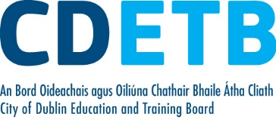

Prompt Payments by Public Sector Bodies

Reporting Template pursuant to Government Decision S29296 of 2 and 8 March 2011 and 28 March 2017 by:

The Health Service Executive, the Local Authorities, State Agencies and all other Public Sector Bodies, (excluding Commercial Semi State bodies)

Parent Government Department: Department of Education and Skills
Public Sector Body: City of Dublin ETB
Quarterly Period Covered: 01 January -31 March 2022

Details | Number | Value  (€) | Percentage (%) of  total number of payments made
Total payments made in Quarter | 8,682 | 14,884,783 | 100%
Payments made within 15 days | 3,611 | 9,390,633 | 41.59
Payments made within  16 days to 30 days | 3,788 | 4,905,421 | 43.63
Payments made in excess of  30 days that were subject to LPI and compensation costs | 49 | 49,586 | .57
Payments made in excess of  30 days that were not subject to LPI and compensation costs | 1,234 | 539,143 | 14.21
Amount of late payment interest (LPI) paid in Quarter | N/A | 252 | N/A
Amount of compensation costs paid in Quarter | N/A | 4,310 | N/A

Signed: Finance Dept

Date: 19/04/22

Please return completed template to: PromptPaymentReturns@education.gov.ie

