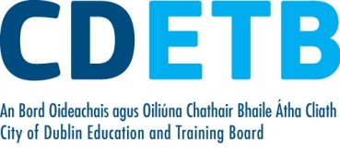
Purchase Order Report 2021 - Quarter 2

Purchase Orders over €20,000 by Quarter

Purchase Orders of €20,000 or above for
City of Dublin Education and Training Board
2nd Quarter 2021

PO Number | Supplier | Total | Description | Paid
PO737009 | Dell Computers | 411,848.68 | Servers | Y
PO737230 | Capita IB Solutions Ltd | 112,452.75 | Online Grants | Y
PO738328 | Mediavest | 51,000.00 | SUSI Media Plan | Y
PO739968 | Dell Computers | 30,517.53 | Desktop Computers | Y
PO739929 | Evros | 25,530.78 | Hosting | Y
PO735144 | Autoaddress | 22,755.00 | Licensing | Y
PO737144 | CSE Entertainment | 20,000.00 | Fitness Equipment | Y
4500502563 | Lufthansa Technik | 199,800.00 | Training | Y

Please note:
- Purchase orders are inclusive of VAT where appropriate.
- Withholding Tax or Relevant Contracts Tax will be deducted from payments where appropriate and accordingly the payment amount may fall below €20,000.
- Although a purchase order may have been raised, it may not yet have been paid. In these cases a “N” will appear in the column to the right. Where part payment has been made to a supplier a “P” will appear in the column to the right. If full payment has been made then Y (Yes) will appear in the column to the right.
- The report includes payments for goods and services. It does not include reimbursements or Grant-in-Aid payment.
Some purchase orders may be excluded if their publication would be precluded under disclosure of commercially sensitive information.

