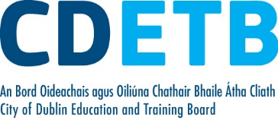

Prompt Payments by Public Sector Bodies

Reporting Template pursuant to Government Decision S29296 of 2 and 8 March 2011 and 28 March 2017 by:

The Health Service Executive, the Local Authorities, State Agencies and all other Public Sector Bodies, (excluding Commercial Semi State bodies)

Parent Government Department: Department of Education and Skills
Public Sector Body: City of Dublin ETB
Quarterly Period Covered: 01 Apr 2021 – 30 June 2021

Details | Number | Value  (€) | Percentage (%) of  total number of payments made
Total payments made in Quarter | 6,107 | 6,512,834 | 100%
Payments made within 15 days | 2,697 | 4,001,058 | 44.16
Payments made within  16 days to 30 days | 2,254 | 1,940,096 | 36.91
Payments made in excess of  30 days that were subject to LPI and compensation costs | 35 | 15,052 | .57
Payments made in excess of  30 days that were not subject to LPI and compensation costs | 1,121 | 556,628 | 18.36
Amount of late payment interest (LPI) paid in Quarter | N/A | €49.23 | N/A
Amount of compensation costs paid in Quarter | N/A | €1,530.00 | N/A

Signed: Finance Dept.

Date: 21/07/21

Please return completed template to: PromptPaymentRetuns@education.gov.ie

