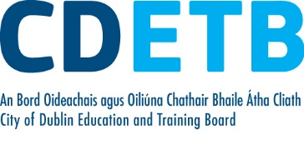

Prompt Payments by Public Sector Bodies

Reporting Template pursuant to Government Decision S29296 of 2 and 8 March 2011 and 28 March 2017 by:

The Health Service Executive, the Local Authorities, State Agencies and all other Public Sector Bodies, (excluding Commercial Semi State bodies)

Parent Government Department: Department of Education and Skills
Public Sector Body: City of Dublin ETB
Quarterly Period Covered: 01 April -30 June 22

Details | Number | Value  (€) | Percentage (%) of  total number of payments made
Total payments made in Quarter | 10,020 | 17,099,842 | 100%
Payments made within 15 days | 5,161 | 13,589,025 | 51.51
Payments made within  16 days to 30 days | 3,492 | 2,931,419 | 34.85
Payments made in excess of  30 days that were subject to LPI and compensation costs | 54 | 28,737 | .54
Payments made in excess of  30 days that were not subject to LPI and compensation costs | 1,313 | 550,661 | 13.10
Amount of late payment interest (LPI) paid in Quarter | N/A | 185 | N/A
Amount of compensation costs paid in Quarter | N/A | 1,960 | N/A

Signed: Finance Dept

Date: 15/07/22

Please return completed template to: PromptPaymentReturns@education.gov.ie

