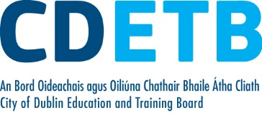

Prompt Payments by Public Sector Bodies

Reporting Template pursuant to Government Decision S29296 of 2 and 8 March 2011 and 28 March 2017 by:

The Health Service Executive, the Local Authorities, State Agencies and all other Public Sector Bodies, (excluding Commercial Semi State bodies)

Parent Government Department: Department of Education and Skills
Public Sector Body: City of Dublin ETB
Quarterly Period Covered: 01 July 2021 - 30th September 2021

Details | Number | Value  (€) | Percentage (%) of  total number of payments made
Total payments made in Quarter | 5,937 | 7,611,056 | 100
Payments made within 15 days | 2,362 | 3,552,680 | 39.78
Payments made within  16 days to 30 days | 2,817 | 3,847,246 | 47.45
Payments made in excess of  30 days that were subject to LPI and compensation costs | 30 | 12,694 | .51
Payments made in excess of  30 days that were not subject to LPI and compensation costs | 728 | 198,437 | 12.26
Amount of late payment interest (LPI) paid in Quarter | N/A | 30 | N/A
Amount of compensation costs paid in Quarter | N/A | 1,240 | N/A

Signed: Finance Dept.

Date: 21/10/21

Please return completed template to: PromptPaymentReturns@education.gov.ie

