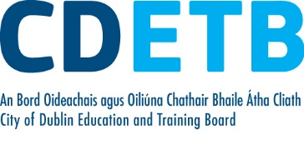

Prompt Payments by Public Sector Bodies

Reporting Template pursuant to Government Decision S29296 of 2 and 8 March 2011 and 28 March 2017 by:

The Health Service Executive, the Local Authorities, State Agencies and all other Public Sector Bodies, (excluding Commercial Semi State bodies)

Parent Government Department: Department of Education and Skills
Public Sector Body: City of Dublin ETB
Quarterly Period Covered: 01 July-30 September 2022

Details | Number | Value  (€) | Percentage (%) of  total number of payments made
Total payments made in Quarter | 7,221 | 14,003,607 | 100%
Payments made within 15 days | 3,912 | 10,734,947 | 54.18
Payments made within  16 days to 30 days | 2,370 | 2,568,448 | 32.82
Payments made in excess of  30 days that were subject to LPI and compensation costs | 26 | 32,783 | .36
Payments made in excess of  30 days that were not subject to LPI and compensation costs | 913 | 667,429 | 12.64
Amount of late payment interest (LPI) paid in Quarter | N/A | 228 | N/A
Amount of compensation costs paid in Quarter | N/A | 1,250 | N/A

Signed: Finance Dept

Date: 26/10/22

Please return completed template to: PromptPaymentReturns@education.gov.ie

